BHARATI VIDYAPEETH’S COLLEGE OF ENGINEERING FOR WOMEN

FDP ON

“RESEARCH OPPORTUNITIES IN SUSTAINABLE DEVELOPMENT USING GIS TECHNOLOGIES”

SPONSORED BY AICTE TRAINING AND LEARNING (ATAL) ACADEMY

11 NOVEMBER 2024

Report on Industry Visit

Location: Maharashtra Remote Sensing Application Centre, Pune.

Resource Person: Dr.Sanjay Patil
Sr. Scientist,MASAC, Pune
Date: 14/11/2024
The insightful explanation by Dr. Sanjay Patil on GIS and remote sensing left a lasting impression, making the session worthwhile. MRSAC, in partnership with Maharashtra's Planning Department, has strengthened its presence by launching centers in Mumbai (2013) and Pune (2014) to enhance project efficiency and decision-making processes. Its training programs, aimed at government officials, NGOs, administrators, and students, focus on soft skills and capacity building. By harnessing cutting-edge technology and a robust thematic digital database, MRSAC empowers Maharashtra with vital scientific insights. Renowned for its expertise in Natural Resource Monitoring and GIS, it remains dedicated to fostering an e-governed, transparent, and thriving state.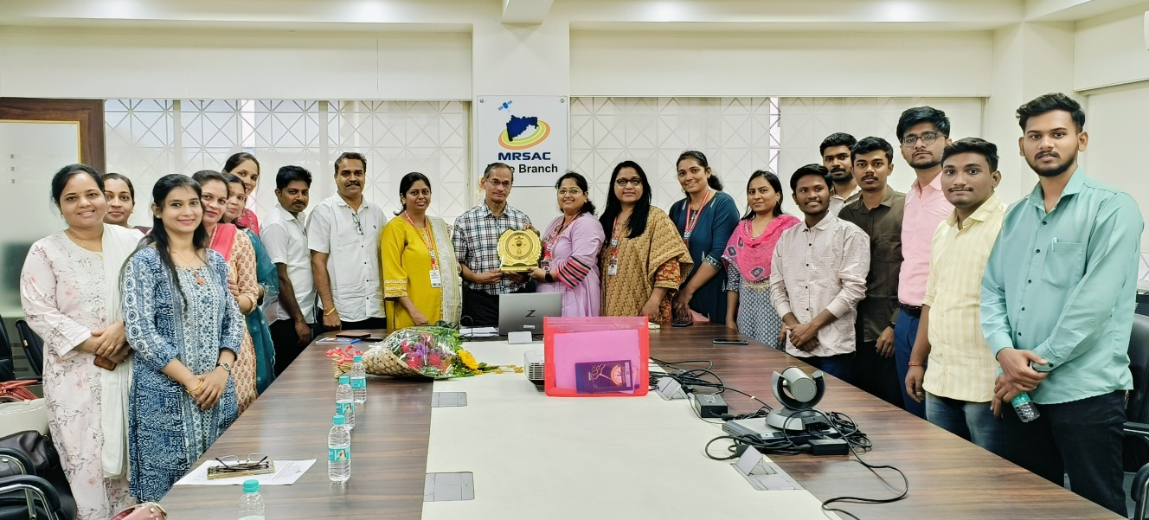
Photo: Industry Visit at MASAC,Pune.
Prepared By
Prof. Mrs. Chetana Hitendra Khairnar

